Supplementary Materials

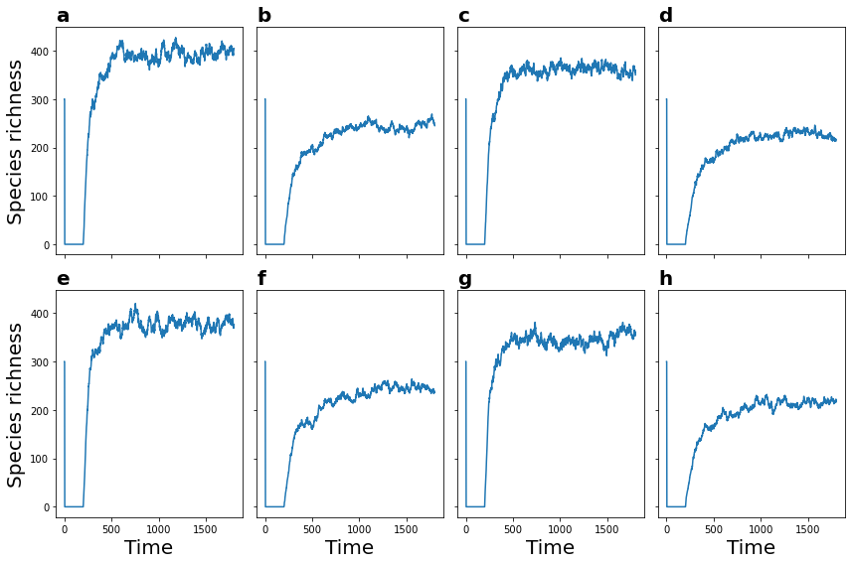

Figure S1 Species richness dynamics across combinations of three parameters: variance for growth rate ($σ_{r}=0.74$), the variance of interaction strength ($σ_{α}=0.36$), and the mean introduction rate ($λ$=1.16). Simulations were conducted for community sizes of 3000, 5000, 7000, 9000, 11000, 13000, 15000, 17000 and 19000 individuals over 1800 time steps. The dynamics of species richness pass through three phases: an initial exponential decline in a closed system over the first 200 time steps, followed by a linear increase associated with species introductions, and finally a plateau corresponding to the stationary state. Community snapshots for the last 1000 time steps (the stationary phase) are used for subsequent analyses.

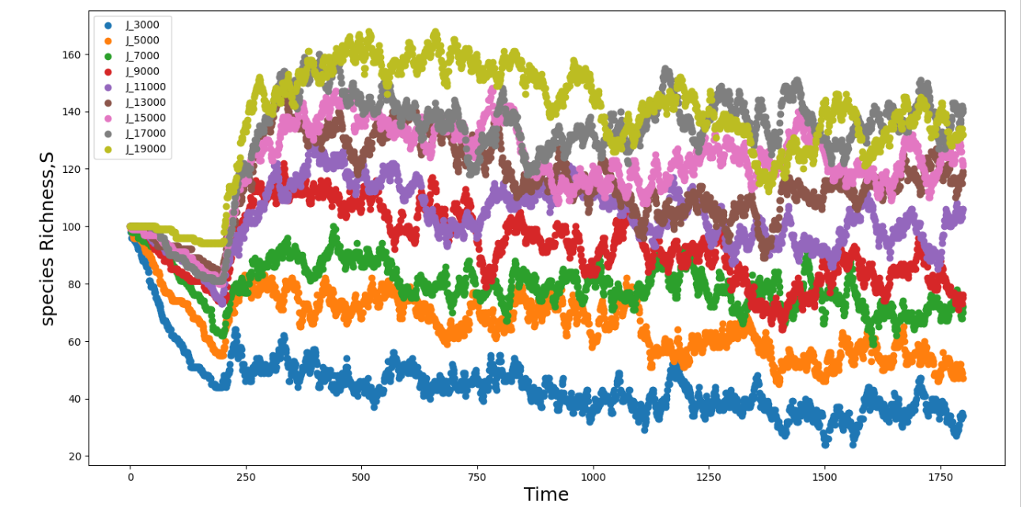
Figure S2 Community size effects on richness dynamics. Temporal dynamics of species richness across communities of varying sizes. Simulations were conducted for community sizes of 3000, 5000, 7000, 9000, 11000, 13000, 15000, 17000 and 19000 individuals over 1800 time steps using the same combinations of $σ_{r},σ_{α}$ and $λ$ as in Figure S1. The results show a positive relationship between community size and species richness, with larger communities consistently supporting higher levels of species richness.

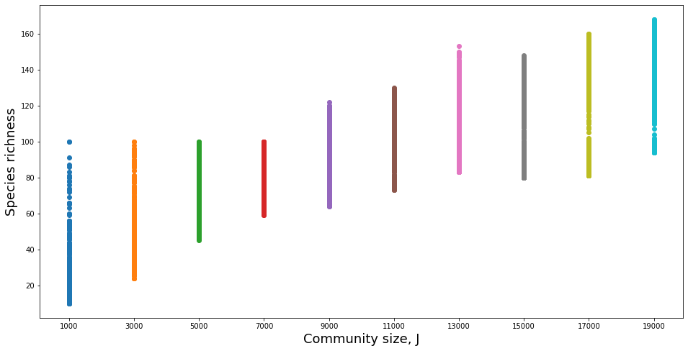
Figure S3 Community size effects on species richness. The figure is showing the 1800 richness values for each J value as in shown differently in Figure S2. Taking the average of the richness per each J value, the $R^{2}$ value for the linear relationship between the J values and species richness is 0.96. Larger communities consistently exhibit higher species richness, underscoring the importance of community size in predicting species richness. The other model parameters are the same as in Figures S2 and S1.

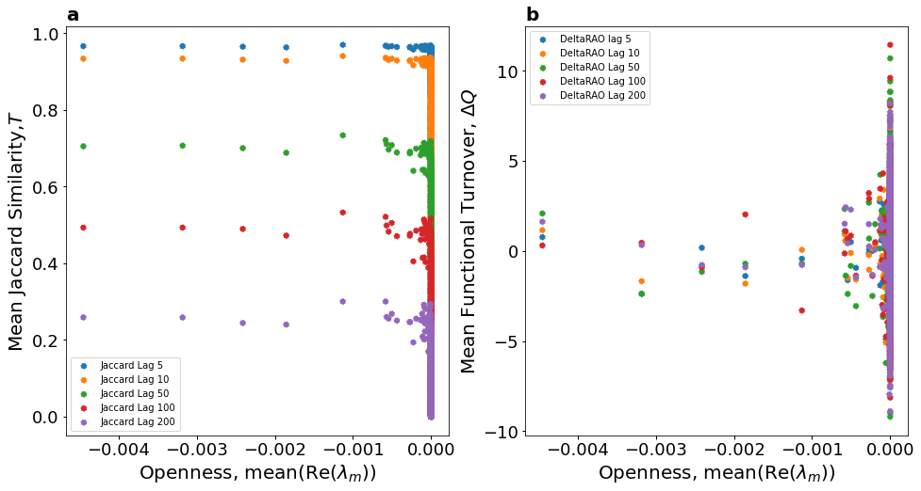

Figure S4 Jaccard Similarity and functional turnover across time lags as a function of the average leading eigenvalue. Panel (a) shows that Jaccard similarity decreases with increasing time lag, indicating greater compositional turnover over longer temporal intervals. Panel (b) shows that community functional turnover exhibits similar dynamics across all time lags, suggesting temporal invariance in functional change patterns. Simulations were conducted for community size of 10000 individuals over 1800 time steps using the combinations of $σ_{r},σ_{α}$ and $λ$ as in the first three columns of sheet 1 in Supplementary Appendix S3.
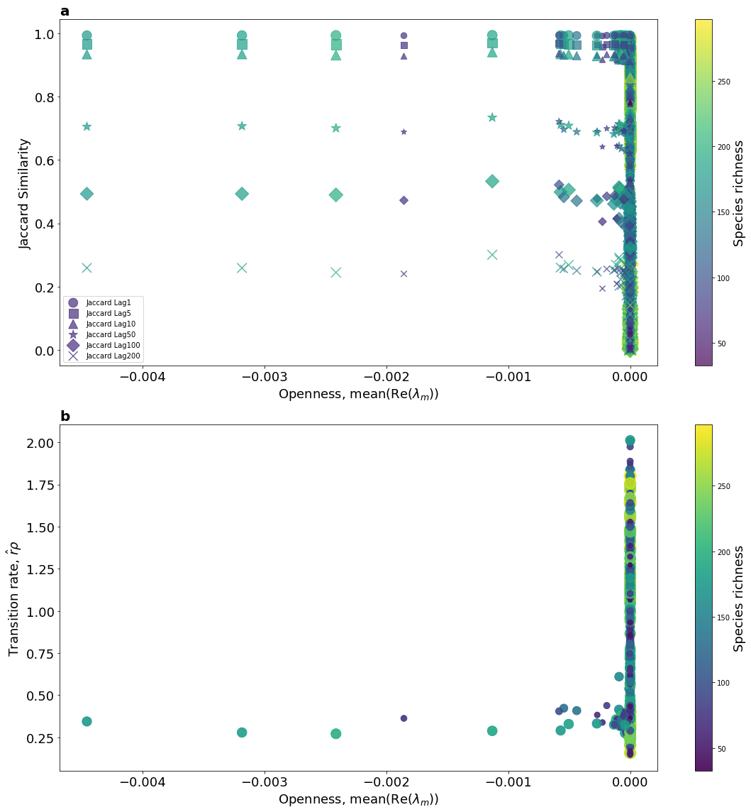
Figure S5 Leading eigenvalue as an indicator of community openness. (a) Time-average Jaccard compositional similarity under different time lags plotted against the time-average real part of the leading eigenvalue for the 1000 simulated communities during the stationary phase. Point size and colour indicate species richness in the community. (b) Transition rate (defined as the product of the average introduction rate and the average intrinsic growth rate) plotted against the time-average real part of the leading eigenvalue for the same 1000 simulated communities during the stationary phase. Simulations were conducted for community size of 10000 individuals over 1800 time steps using the combinations of $σ_{r},σ_{α}$ and $λ$ as in the first three columns of sheet 1in Supplementary Appendix S3
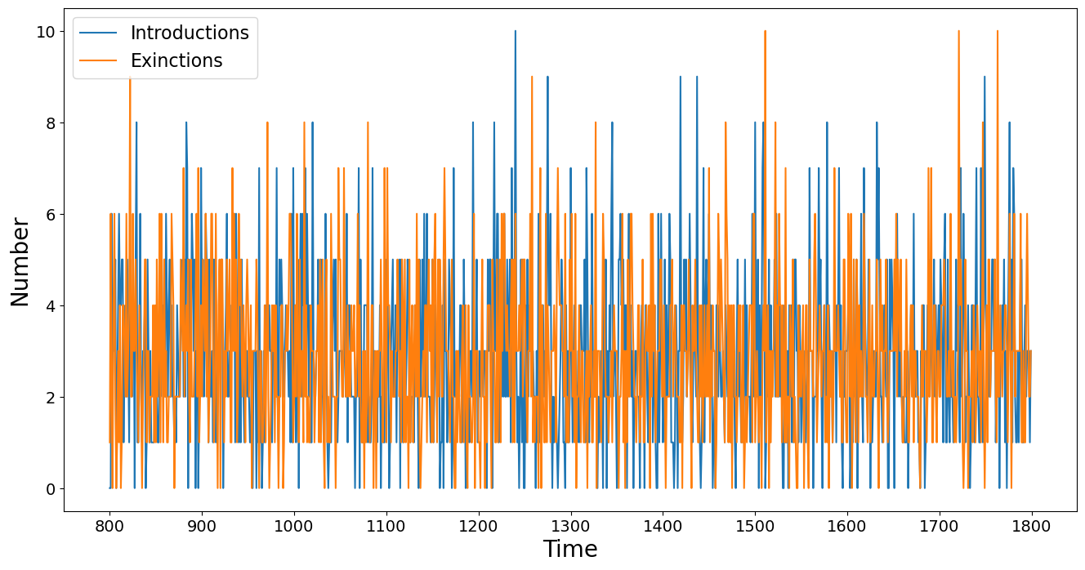
Figure S6 Introduction rate and extinction rates. The plot shows the number of species introduced and the number of species that went extinct over the final 1000 time steps of the simulation. During the stationary phase, introduction and extinction rates converge towards the same equilibrium, indicating a dynamic balance in species turnover. Simulations were conducted for community size of 10000 individuals over 1800 time steps using the same combinations of $σ_{r},σ_{α}$ and $λ$ as in Figure S1

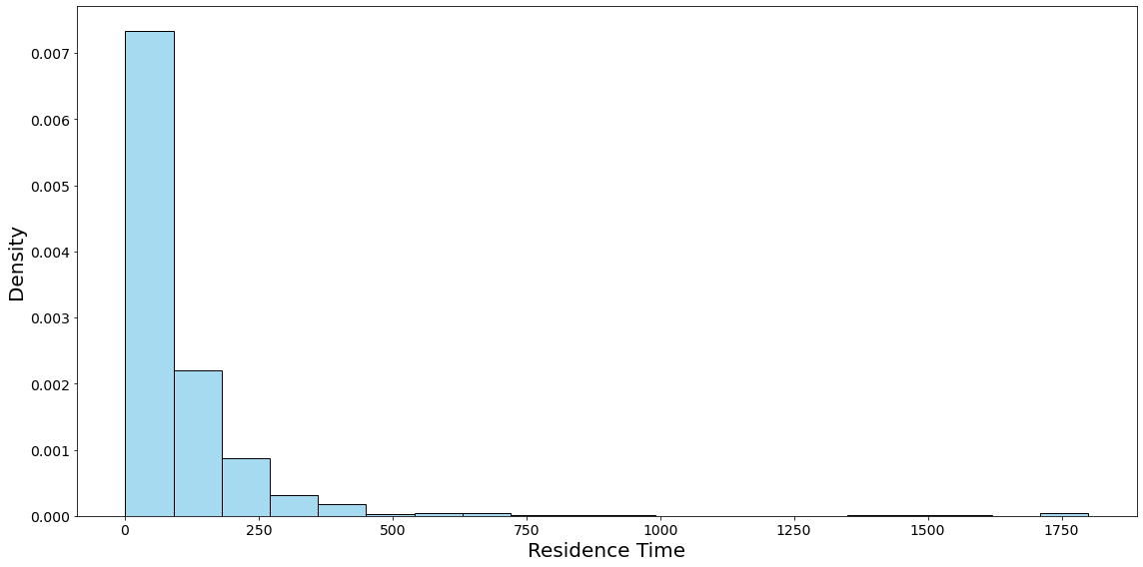
Figure S7 Probability density distribution of the residence time of species. The distribution shows that most species persist for relatively short durations, while a small subset of competitively dominant species remains in the community for more than 1500 time steps. Simulations were conducted for community size of 10000 individuals over 1800 time steps using the same combinations of $σ_{r},σ_{α}$ and $λ$ as in Figure S1.

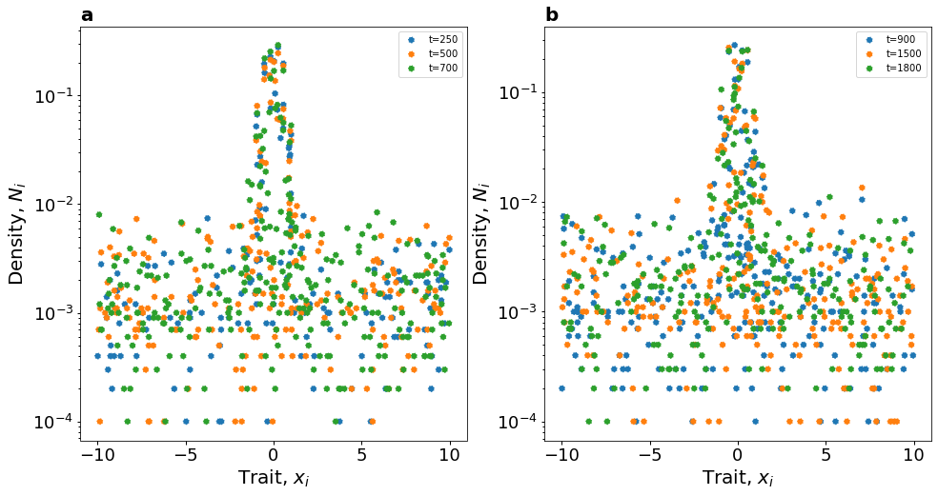
Figure S8 Trait distributions during transient (a) and stationary (b) phases. The density-trait relationship is consistent between the transient and stationary phases, indicating no qualitative change in community trait profile across phases. Simulations were conducted for community sizes of 10000 individuals over 1800 time steps using the same combinations of $σ_{r},σ_{α}$ and $λ$ as in Figure S1. Figure S8 (a) shows the relationship between population density ($N_{i})$ and species traits ($x_{i})$ at three different time snapshots in the transient phase. Similarly, Figure S8 (b) shows the relationship between $N_{i}$ and $x_{i}$ in the stationary phase.

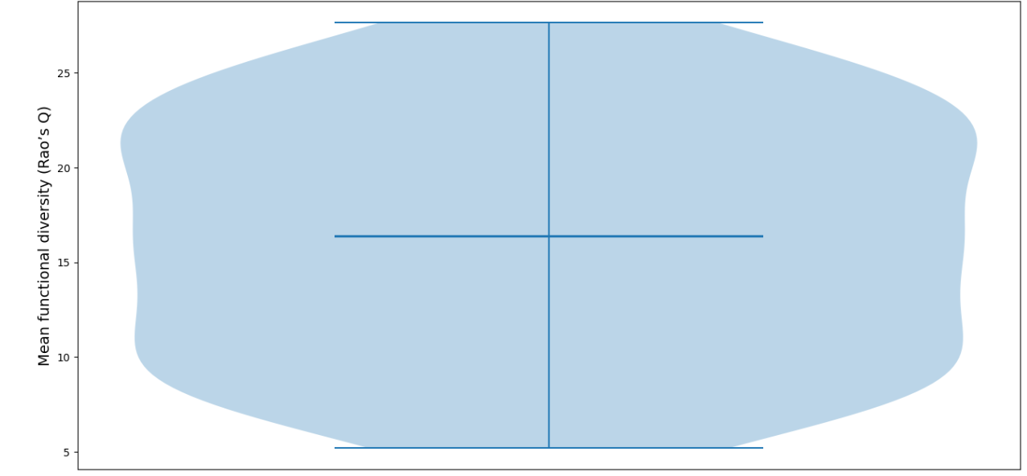
Figure S9 Mean functional diversity across 1000 modelled communities. Mean functional diversity was calculated as the average value over the final 1000 time steps during the stationary phase of the simulations. The mean functional turnover for each community is shown in the column ‘AR’ of sheet 1 in Supplementary Appendix S3, and the corresponding values of $σ_{r},σ_{α}$ and $λ$.

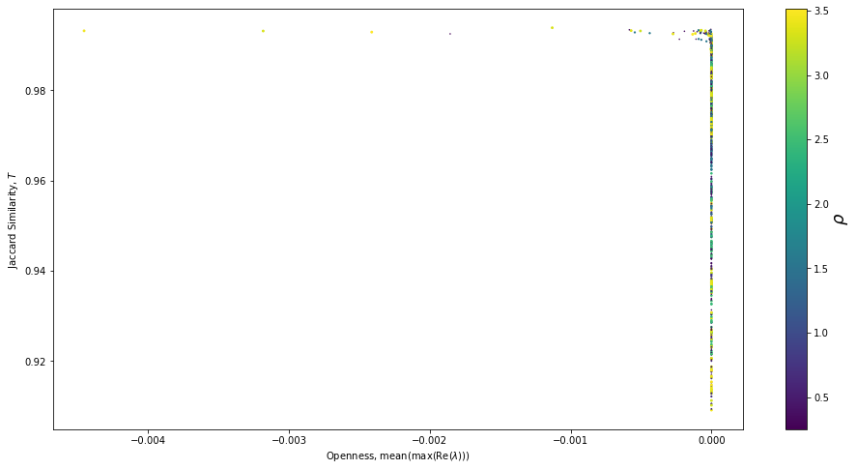
Figure S10 Leading eigenvalue as an indicator of community openness. The time-average Jaccard compositional similarity at lag 1 plotted against the time-average real part of the leading eigenvalue for the 1000 simulated communities during the stationary phase. Simulations were conducted for a community size of 10000 individuals over 1800 time steps using the combinations of $σ_{r},σ_{α}$ and $λ$ as in the first three columns of sheet 1 in Supplementary Appendix S3. The average value was calculated over the final 1000 time steps during the stationary phase of the simulations. Point size and colour indicate the mean introduction rate in each community.

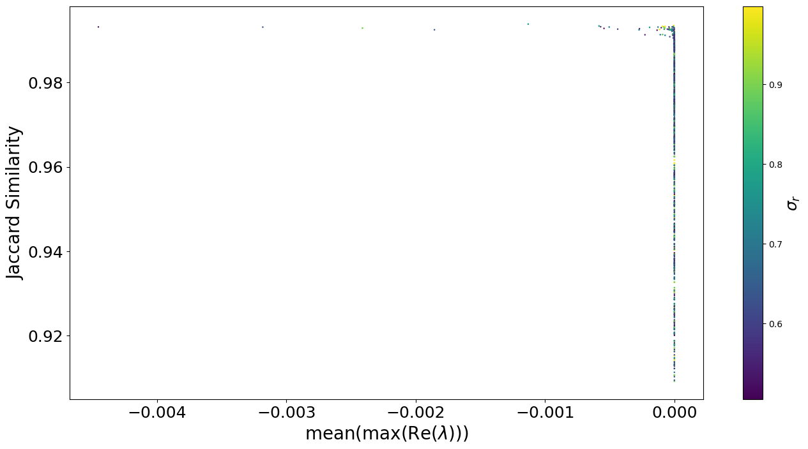
Figure S11 Leading eigenvalue as an indicator of community openness. The time-average Jaccard compositional similarity at lag 1 plotted against the time-average real part of the leading eigenvalue for the 1000 simulated communities during the stationary phase. Point size and colour indicate the width of intrinsic growth rate Gaussian kennel. Simulations were conducted for community size of 10000 individuals over 1800 time steps using the combinations of $σ_{r},σ_{α}$ and $λ$ as in the first three columns of sheet 1 in Supplementary Appendix S3. The average value was calculated over the final 1000 time steps during the stationary phase of the simulations.

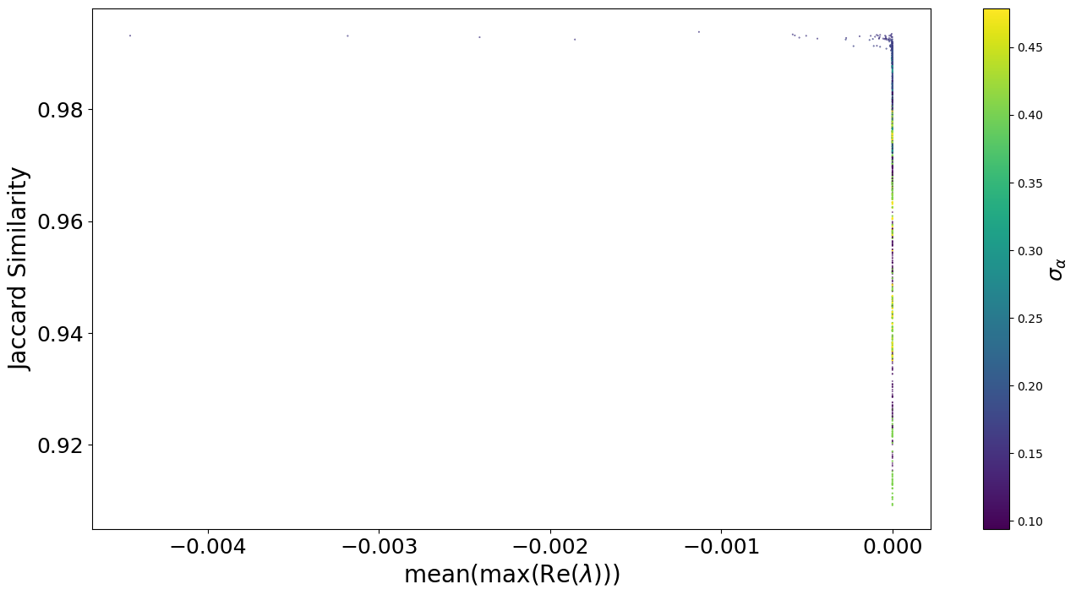
Figure S12 Leading eigenvalue as an indicator of community openness. The time-average Jaccard compositional similarity at lag 1 plotted against the time-average real part of the leading eigenvalue for the 1000 simulated communities during the stationary phase. Point size and colour indicate the width of interaction strength Gaussian kennel. Simulations were conducted for community size of 10000 individuals over 1800 time steps using the combinations of $σ_{r},σ_{α}$ and $λ$ as in the first three columns of sheet 1 in Supplementary Appendix S3. The average value was calculated over the final 1000 time steps during the stationary phase of the simulations. 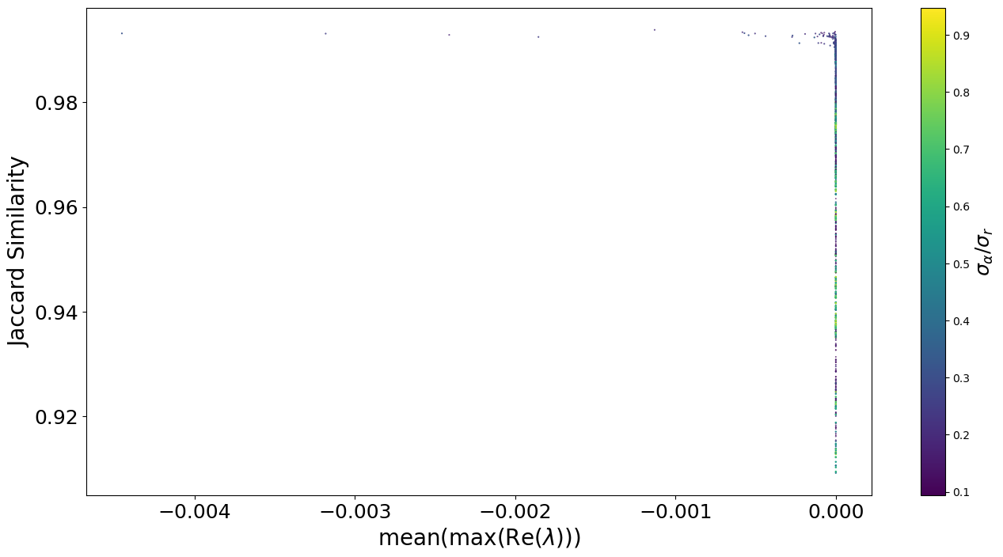
Figure S13 Leading eigenvalue as an indicator of community openness. The time-average Jaccard compositional similarity at lag 1 plotted against the time-average real part of the leading eigenvalue for the 1000 simulated communities during the stationary phase. Point size and colour indicate the ratio of the width of interaction strength to the width of intrinsic growth rate. Simulations were conducted for community size of 10000 individuals over 1800 time steps using the combinations of $σ_{r},σ_{α}$ and $λ$ as in the first three columns of sheet 1 in Supplementary Appendix S3. The average value was calculated over the final 1000 time steps during the stationary phase of the simulations.

